Innosphere Ventures Application
Congratulations – you’ve taken a big step for the future of your company, and we want to thank you for completing and submitting this application!

SELECT WHICH PROGRAM(S) YOUR COMPANY/TECHNOLOGY IS APPLYING FOR:
☐ Innosphere’s commercialization program for entrepreneurs, founders and CEOs of science and technology-based companies or technologies. Deadline to apply for this program is September 8th, 2021.
☐ I’m applying for funding consideration.
☐ I’m applying to the SAGE program for pro bono advising.

DIRECTIONS:
- Complete this application to the best of your ability. This isn’t intended to take a lot of your time, and typically takes around 60-90 minutes or less to complete.
- Email this application to Innosphere’s COO: scott@innosphereventures.org
Optional: If you have additional documents such as an investor pitch deck or business plan, you may attach those in your email as well; however, please limit your additional attachments to only two extra documents.
- Save the application using the following convention for the title: “CompanyName_InnosphereApplication”.
- You will hear back from Innosphere within the week!

YOUR INFORMATION:
First and last name:

Are you founder/co-founder, CEO, or other position within this company:

Email:

Your LinkedIn profile:

Paste LinkedIn URLs or bios for current team:

Your direct phone number:

COMPANY INFORMATION:
Company name (if no company name, please just list name of technology):

Physical Address:

Company phone number:

Website:

Is your company on social media platforms that Innosphere should follow?

THE 15 APPLICATION QUESTIONS:
1. Describe your business and the problem(s) that your product/solution solves.

2. Describe the market you are targeting and your initial target customers. How many of them have you interviewed about the problem you’re solving and the need for your solution? What is your estimate of the total addressable market?

3. What is the value proposition to your target customer?

4. Describe your business model – how do you generate sales and ultimately make a profit.

5. How is the problem you’re solving, solved today? Who are your competitors and how will you differentiate your solution?

6. Describe your initial go-to-market plan. Include information on your sale strategies including channel partners.

7. Describe your current traction with customers (users, customers, pilots, revenue) and the development state of your product/solution.

8. How much capital (grants, friends and family, outside investors) have you currently raised and from what sources?

9. How much funding do you anticipate needing in the next 12 months? What funding sources will you pursue? What business milestones does this funding help you achieve? If your company goal is to exit, what is the anticipated total funding needed to reach an exit?

10. What are your specific goals for the business over the next 12 months?

11. What challenges will you face over the next 12 months?

12. What gaps do you have on your team?

13. If available, provide a URL where we can access your company Demo:

14. What are the top three things Innosphere Ventures’ program and mentors can help you accomplish?

15. Last question! How did you hear about Innosphere? For example: an event you attended; an email; from a colleague; from another organization; etc.

YOU’RE DONE!
- Email this application to Innosphere’s COO: scott@innosphereventures.org.
Optional: If you have additional documents such as an investor pitch deck or business plan, you may attach those in your email as well; however, please limit your additional attachments to only two extra documents max.
- Save the application using the following convention for the title: “CompanyName_InnosphereApplication”.
- You will hear back from Innosphere within the week!

Sincerely,
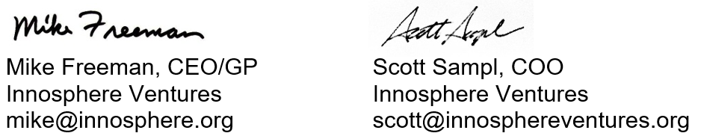

For more information on Innosphere Ventures and our programs for entrepreneurs building high-tech companies, please visit www.innosphereventures.org/entrepreneurs/

