Innosphere Ventures Application
Congratulations – you’ve taken a big step for the future of your company, and we want to thank you for completing and submitting this application!

SELECT THE PROGRAM(S) FOR WHICH YOU ARE APPLYING:
☐ The new Life Sciences Incubation Program
☐ The SAGE program for early-stage startup companies to receive pro bono advising.
☐ Innosphere’s Incubation & Commercialization Program (Innosphere runs a variety of programs for founders commercializing technologies and products in science and technology-based sectors, such as the REACH Energy Accelerator)

DIRECTIONS:
- Complete this application to the best of your ability. This typically takes around 60-90 minutes or less to complete.
- Email this application to Innosphere’s COO: scott@innosphereventures.org
Optional: If you have additional documents such as an investor pitch deck or business plan, you may attach those in your email as well; however, please limit your additional attachments to only two extra documents.
- Save the application using the following convention for the title: “CompanyName_InnosphereApplication”.

YOUR INFORMATION:
First and last name:

Your position in this company (founder/co-founder, CEO, etc.)

Email:

LinkedIn profile:

Phone number and/or company phone number:

COMPANY INFORMATION:
Exact spelling of company name (if no name, please list name of technology):

Headquartered/Physical Address:

Website (if no website, link to an article that mentions your work, if appliable):

If your company or technology has a University affiliation, please briefly describe that university or licensing relationship:

Click the diversity, equity, and inclusion (DEI) statements that are true for your startup:
☐ Team/founder(s) include Black, Indigenous and People of Color (BIPOC)
☐ Team/founder(s) include a woman/women
☐ Team/founder(s) include veteran(s)
☐ Team/founder(s) include person/people with disabilities
☐ Team/founder(s) include a non-binary person; a lesbian, gay, bisexual, transgender, or queer (LGBTQ+) person/people
☐ The technology being developed is targeted at a population which is adversely affected by low socioeconomic status or inequality. A technology with a “significant impact on disadvantaged communities” is defined as a service or product that benefits accrue to disadvantaged communities at a greater rate than to the population at large.
☐ Startup is based/headquartered in a rural area
☐ Other:

THE 15 APPLICATION QUESTIONS:
1. Describe your business and the problem(s) that your product/solution solves.

2. Describe the market you are targeting and your initial target customers. How many of them have you interviewed about the problem you’re solving and the need for your solution? What is your estimate of the total addressable market?

3. What is the value proposition to your target customer?

4. Describe your business model – how do you generate sales and ultimately make a profit?

5. How is the problem you’re solving, solved today? Who are your competitors and how will you differentiate your solution?

6. Describe your initial go-to-market plan. Include information on your sale strategies including channel partners.

7. Describe your current traction with customers (users, customers, pilots, revenue) and the development state of your product/solution.

8. How much capital (grants, friends and family, outside investors) have you currently raised, and from what sources?

9. How much funding do you anticipate needing in the next 12 months? What funding sources will you pursue? What business milestones does this funding help you achieve?

10. Only if your company goal is to exit, what is the anticipated total funding needed to reach an exit?

11. What are your specific goals for the business over the next 12 months?

12. What challenges will you face over the next 12 months?

13. What gaps do you have on your team?

14. If available, provide a URL where we can access your company Demo:

15. What are the top three things that this incubation/commercialization program and mentors can help you accomplish?

16. Last question! How did you hear about this opportunity for your startup? (e.g. university referral, mentor, online, an event you attended, an email, from a colleague; from another organization, etc.)

YOU’RE DONE!
- Email this application to Innosphere’s COO: scott@innosphereventures.org.
Optional: If you have additional documents such as an investor pitch deck or business plan, you may attach those in your email as well; however, please limit your additional attachments to only two extra documents max.
- Save the application using the following convention for the title: “CompanyName_InnosphereApplication”.
- You will hear back from us soon!

Sincerely,
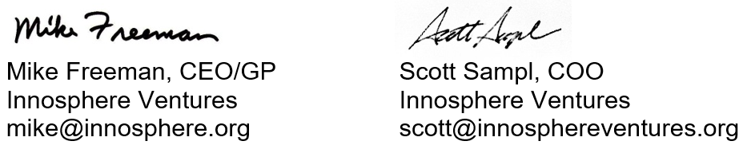

For more information on Innosphere Ventures and our programs for entrepreneurs commercializing technologies and building high-tech companies, please visit www.innosphereventures.org

