**NSF ASCEND Engine Announces an Additional $2 Million in Grants to Seven Teams Across Colorado and Wyoming**

**Fort Collins, CO** – The NSF ASCEND Engine in Colorado and Wyoming is delighted to announce the grantees of its most recent round of R&D and translation grant opportunities. This round of projects reflects our updated, unifying investment theme of *Advanced Sensing and Computation for Environmental Decision Making* (ASCEND). Grants were awarded to qualifying startups and universities working on accelerating the research, development, and commercialization of innovations in advanced sensing and computation that lead to tangible products, services, or solutions for environmental decision making.

“Our second round of investments reflects how the NSF ASCEND Engine is helping to connect the dots across our ecosystem, transforming an unparalleled foundation of multi-modal data from our research partners into actionable insight in both commercial and public benefit use cases through cutting-edge data science techniques.” Said Dr. Sam Malloy, Use Inspired R&D Director at the NSF ASCEND Engine. “Our Round 2 awardees add substantial technical prowess to our portfolio and will help to develop the foundational R&D/Translation infrastructure that will position us for success in the Emergent Phase (years 3-5) of the Engine program.”

The ASCEND Engine received nearly 90 concepts across two areas:

* The **Use-Inspired R&D Grant Program** fosters innovative activity leading to high-impact data products or technologies that create a foundation for future translational activities.
* The **Translation Grant Program** supports and accelerates startup companies commercializing innovations into viable products, services, or solutions.

The winning projects address key environmental challenges in our region, including wildfire smoke forecasting, post-wildfire water quality, and soil health in the context of aridification. These projects build on and strengthen critical capabilities in advanced sensing and data science, positioning Colorado and Wyoming at the forefront of innovation nationally. These projects demonstrate the power of public-private partnerships and investments in innovation to drive meaningful impact.

## Winners of the ASCEND Engine RFP:

### Use-Inspired Research and Development

**Category:** Wildfire Preparedness and Response/Air Quality

**Project Title:** *RADSENSE: Rapid Analytics and Deployment of Sensor Networks for Emergencies*

**Principal Investigator:** John Volckens

**Lead Institution:** Colorado State University

**Key Partners:** Colorado Department of Public Health and Environment (CDPHE), CO Office of Economic Development and Trade (OEDIT)

**Category:** Water Quality and Availability

**Project Title:** *Scalable, data-driven water quality forecasting for municipal water supply*

**Principal Investigator:** Mathew Ross

**Lead Institutions:** Colorado State University and University of Wyoming

**Key Partners:** Upper Cache La Poudre Research, Northern Water, Cities of Fort Collins, Greely, and Thornton.

**Category:** Water Quality and Availability

**Project Title:** *Rapid Development and Validation of Nutrient and Bacterial In-Situ Water Quality Sensors and Geospatial Analytics for Watershed Management*

**Principal Investigator:** Evan Thomas

**Lead Institution:** Virridy

**Key Partners:** In-Situ Inc., Mortenson Construction, Denver Water, National Ecological Observatory Network (NEON)

**\*New Category*:** Cross-Cutting R&D and Translation Infrastructure

**Project Title:** *Experimental Digital Twin for Ecosystems: Water, Soil, Drought*

**Principal Investigator:** Mike SanClements

**Company Name:** National Ecological Observatory Network (NEON) operated by Battelle Memorial Institute

**Key Partners:** National Renewable Energy Laboratory (NREL), NVIDIA, PAGE Technologies

**\*New Category*:** Cross-Cutting R&D and Translation Infrastructure

**Project Title:** *Accelerating Digital Twins with Surrogates and Scientific Machine Learning*

**Project Team Lead:** Joshua Day

**Company Name:** Rallypoint

**Key Partners:** JuliaHub Inc., National Ecological Observatory Network (NEON), CU Boulder’s Earth Lab

### Translation

**Project Category:** Soil Health

**Project Title:** *Translating advanced infrared spectroscopy sensing and data analytics for the commercialization of innovative, high throughput and low-cost soil health monitoring*

**Project Team Lead:** Samantha Mosier

**Company Name:** Cquester Analytics

**Key Partners:** Colorado Department of Agriculture, Nature Based Solutions in Shell

**Project Category:** Water Quality and Availability

**Project Title:** *Creek Protection Partnership & Stormwater Filter Innovation*

**Project Team Lead:** Brian Deurloo

**Company Name:** Frog Creek Partners

**Key Partners:** Colorado School of Mines, Maroon Industries, Laramie County Conservation District, City of Cheyenne, Bonneville.

###

**About the ASCEND Engine in Colorado and Wyoming:**

Led by Innosphere and funded by the U.S. National Science Foundation (NSF), with support from the State of Colorado and the State of Wyoming, the ASCEND Engine is a collaborative initiative focused on driving innovation across the Colorado-Wyoming region. The ASCEND Engine brings together a diverse network of partners to develop and commercialize technologies that address critical community resilience challenges, foster economic growth and enhance community well-being. Visit [www.co-wyengine.org](https://www.co-wyengine.org/) for more information.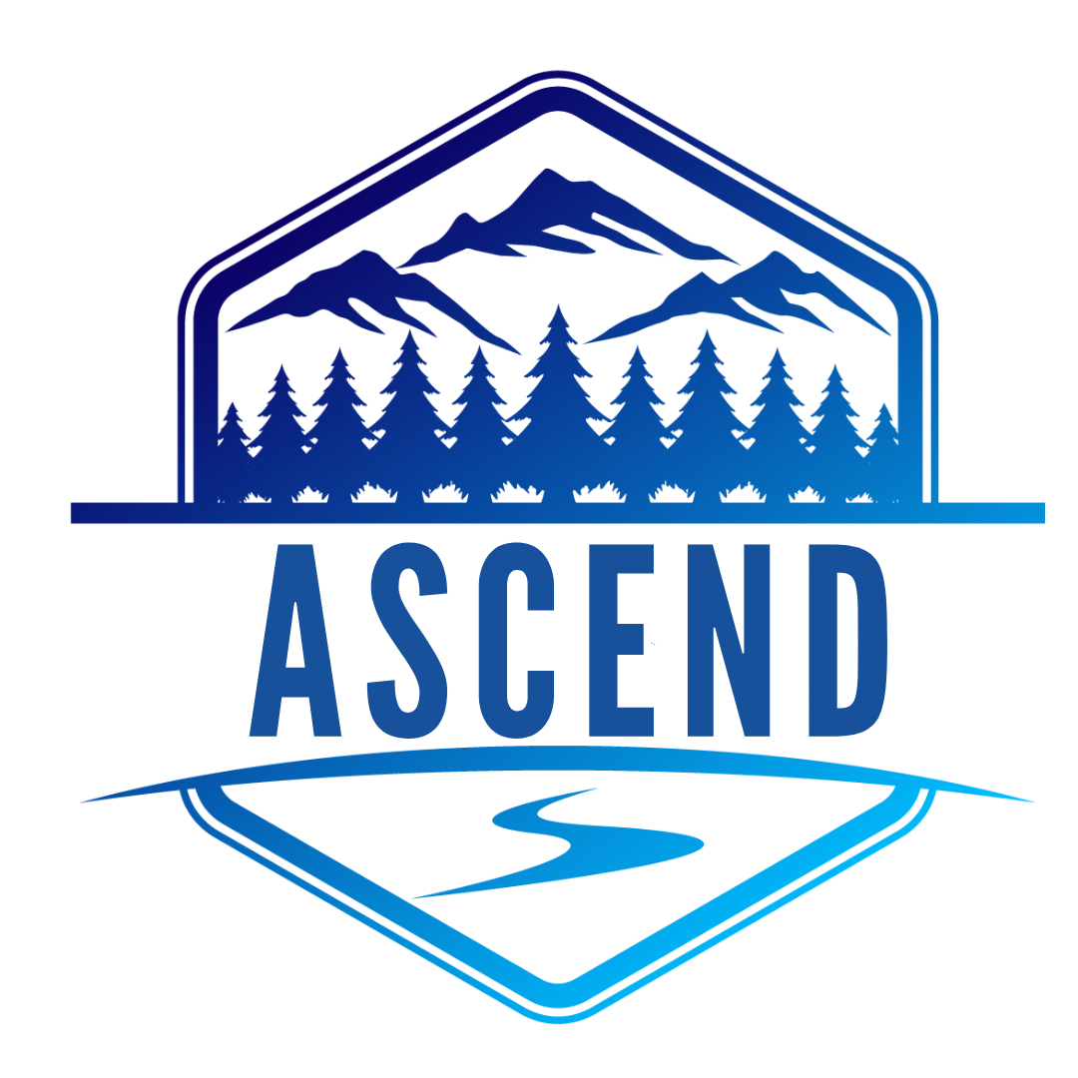

**More about Innosphere**

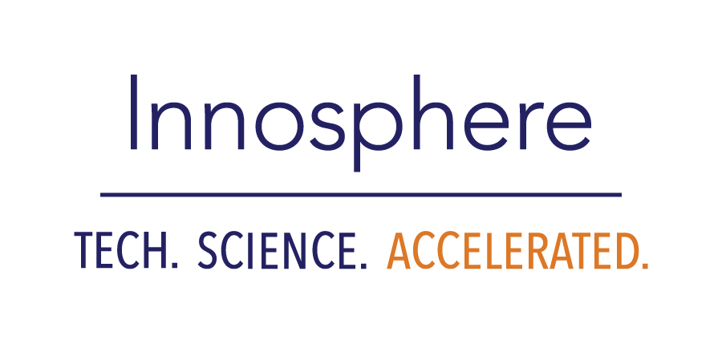Innosphere accelerates the success of start-up founders building and commercializing technology and science-based companies, using comprehensive incubation programs, modern office and lab spaces, workforce initiatives, grants, and venture capital, Innosphere is an award-winning 501(c)(3) non-profit organization with a 27-year history of success in its mission to grow the region’s entrepreneurship and innovation ecosystem.

Visit  [www.innosphere.org](http://www.innosphereventures.org/) to learn more.